**DYSA Dugout Cheers**

So long as cheers are positive, focused on our own team building, and not belittling or heckling the other team or individuals, then cheering should be encouraged.

**We’re gonna win, not lose, not tie the score**

We’re gonna beat ‘em, crush ‘em, that’s our custom

Gooooooo (team name)!

**Hi my name is (name), do you know what I got? (What do you got?)**

I got a team that’s smoke’n hot! (How smoke’n hot?!)

Grand slams and home runs, too! (Ah Ha Ah Ha!)

Let’s see what (name) can do!!!

**Hi ho, hi ho, (sung to the 7 dwarfs)**

It's off to first we go,

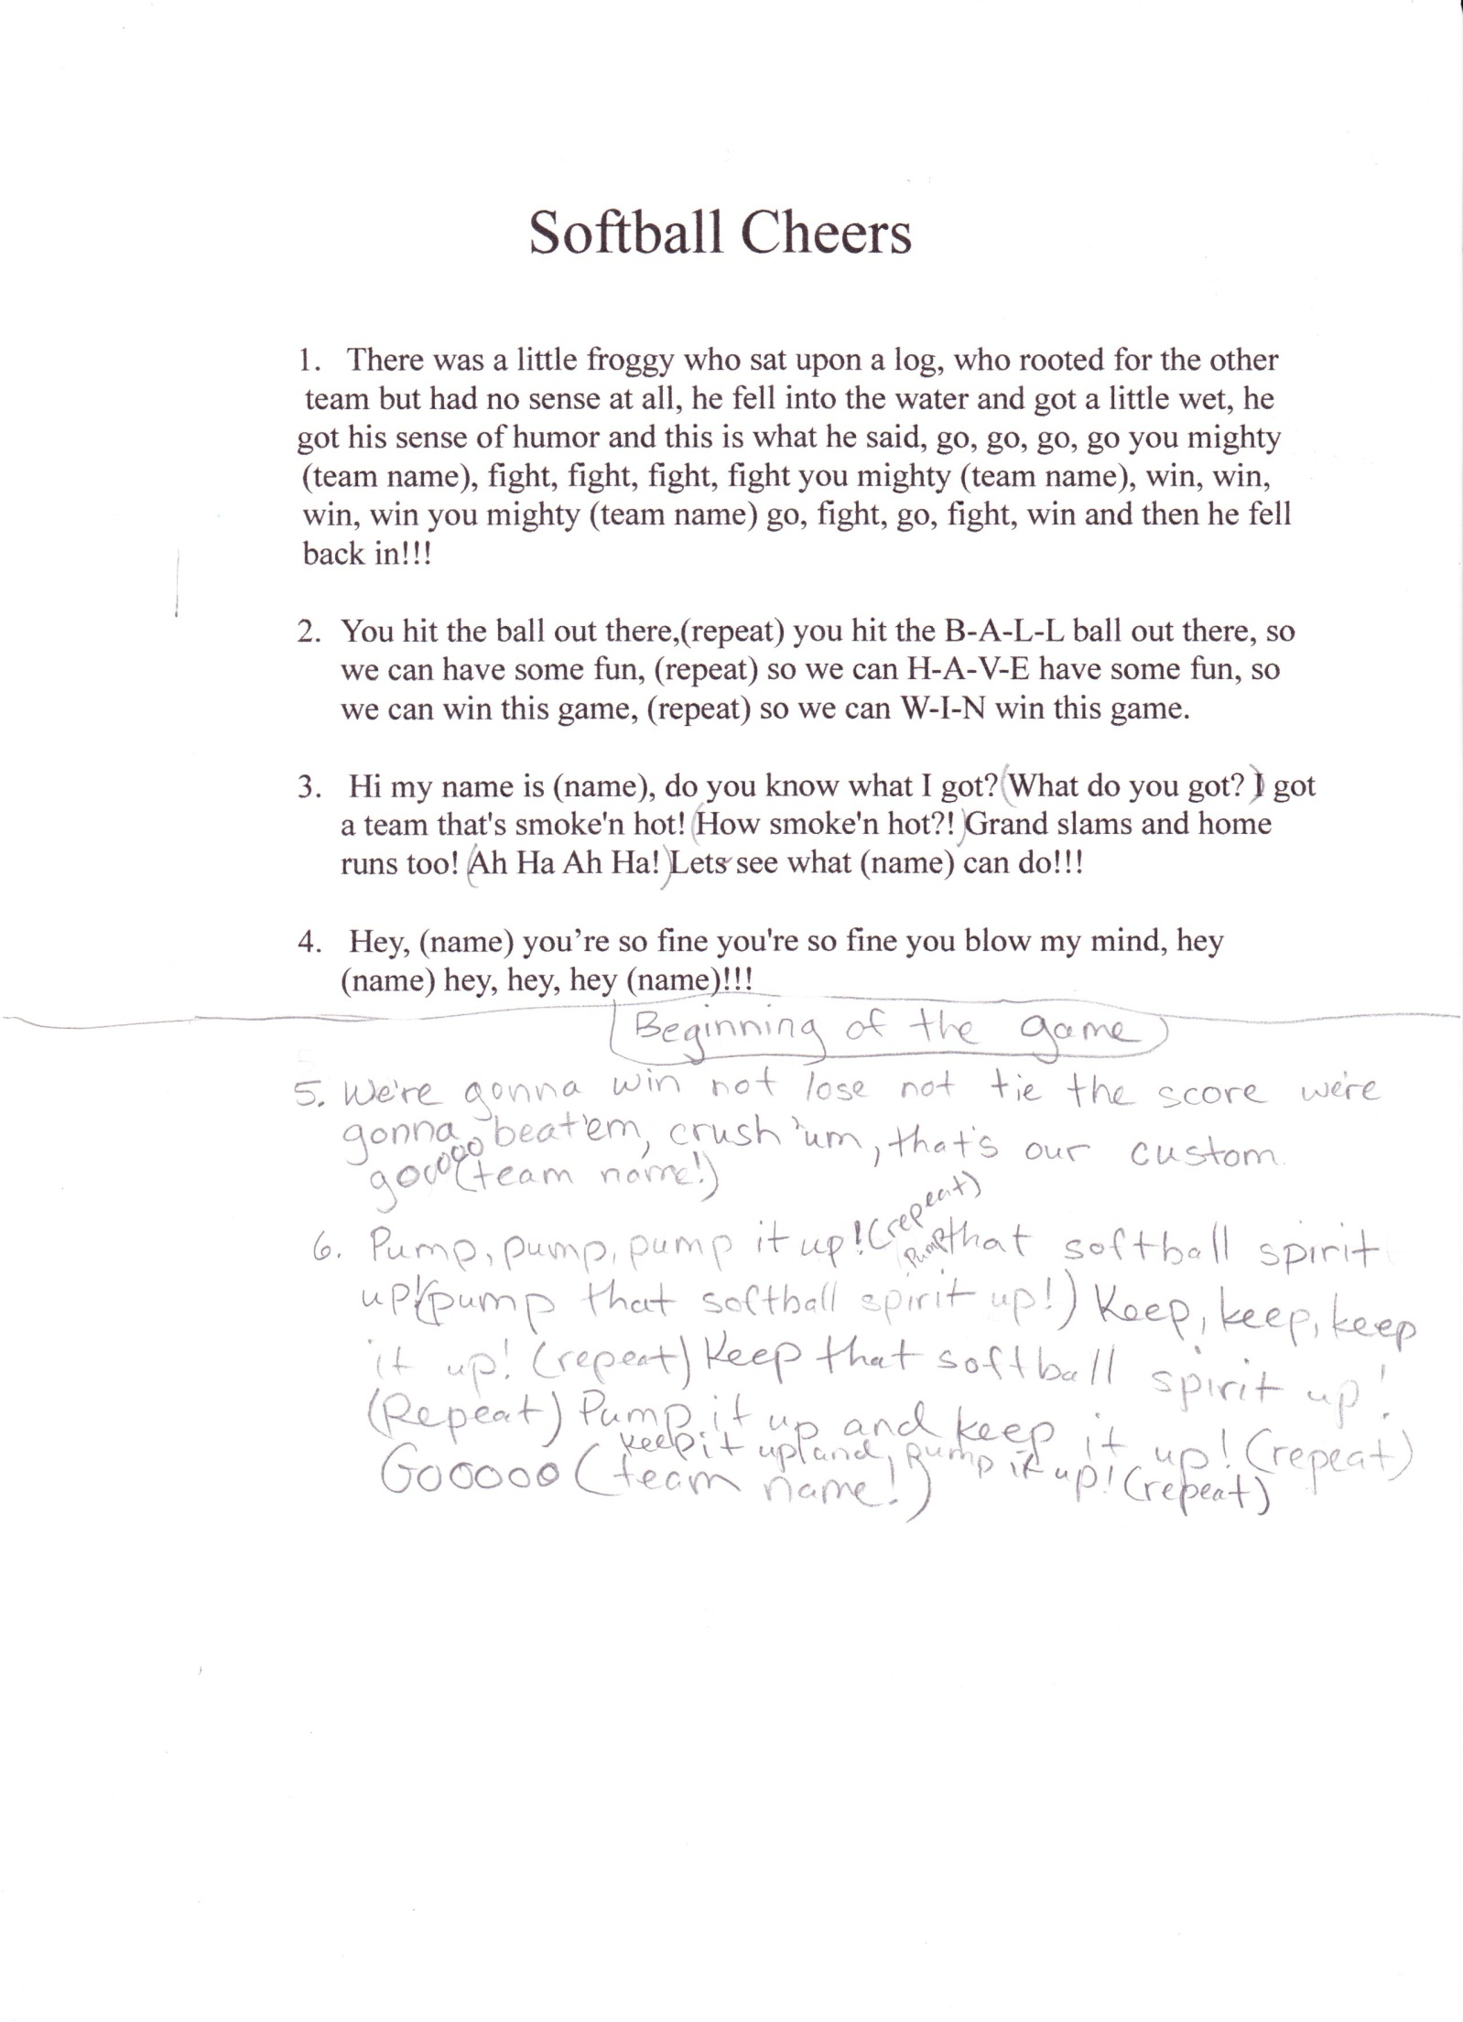Then second then third then home again.

Hi ho hi ho hi ho hi ho.

**There was a little froggy sitting on a log**

Chirping so loudly we could barely play ball

The batter hit a foul ball that landed on his head

And when he got back up again this is what he said:

“Go, go go, go you mighty (team name),

“Have fun, fun fun, have fun you mighty (team name),

“Win, win win, win you might (team name),

“Go, have fun, go, have fun, win! …ribbit, …ribbit.

**You hit the ball out there, (repeat) you hit the B-A-L-L ball out there, so**

We can have some fun, (repeat) so we can H-A-V-E have some fun, so

We can win this game, (repeat) so we can W-I-N win this game.

**Pump, pump, pump it up! (repeat)**

Pump that softball spirit up! (repeat)

Keep, keep, keep it up! (repeat)

Keep that softball spirit up! (repeat)

Pump it up and keep it up! (repeat)

Goooooooo (team name)!

**Hey, (name) you’re so fine, you’re so fine you blow my mind**

Hey, (name) hey, hey, hey (name)!!!

**2 – 4 – 6 – 8, who do we appreciate**

(opponent’s team name) (opponent’s team name) hooray!

**Potato chips, potato chips:  munch, munch, munch!**

We think the (opponent’s team name) are a mighty fine bunch!